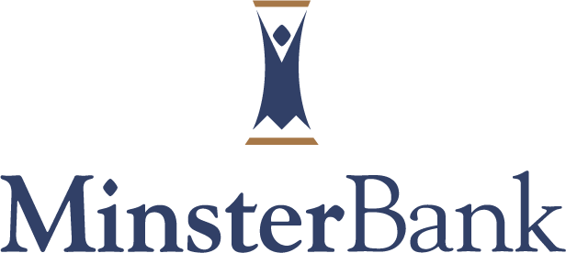
Community Shred Day makes a difference.

Sidney‐Shelby Crime Stoppers and Minster Bank made a difference in Identity Theft Prevention by sponsoring a free Community Shred Day on September 12, 2009 at the Sidney office of Minster Bank at 117 West Russell Road, Sidney.

A Shred-It® mobile shredding truck was on site and destroyed confidential documents such as bank statements, credit card solicitations, and financial statements. The paper was then recycled. One hundred and one vehicles participated. Over 7,000 pounds of paper was shredded and this resulted in 39 trees being saved.

As the fastest-growing form of fraud, identity theft and corporate espionage threatens to destroy personal credit ratings as well as a person’s reputation and security. Governments and regulators around the world continue to develop legislation to help protect individuals and businesses. Prevention is the best solution-once the documents are shredded; they cannot be reassembled.

Minster Bank, a local community bank, and a subsidiary of Minster Financial Corp., is headquartered in Minster, Ohio, and has offices located in Minster, New Bremen, St. Marys, Wapakoneta, Sidney, and Troy. Visit www.minsterbank.com to learn more about Minster Bank.

